AI LAB
assisment-14.5
2503A52l17

Lab 14: Web Design Application – AI-Assisted HTML/CSS/JS
Generation
Lab Objectives
• Design functional, visually appealing web applications using
HTML, CSS, and JavaScript with AI assistance.
• Apply responsive, accessible, and interactive design
Week 7 -
Friday
principles.
• Create practical UI components for real-world web applications.
• Use AI to optimize layout, UX, and performance
Task 1: AI-Assisted Portfolio Website
Scenario:
A student wants to showcase their projects, skills, and contact details in
a portfolio website. Instead of writing all code manually, they want to
speed up the process using GitHub Copilot.
• Use Copilot to generate an HTML structure for a personal
portfolio page (sections: Home, About, Projects, Contact).
• Ask Copilot to suggest responsive CSS styling for the layout
(e.g., grid/flexbox).
• Customize Copilot’s suggestions to add a hover effect on project
cards

HTML FILE FOR THE PRO GRAM 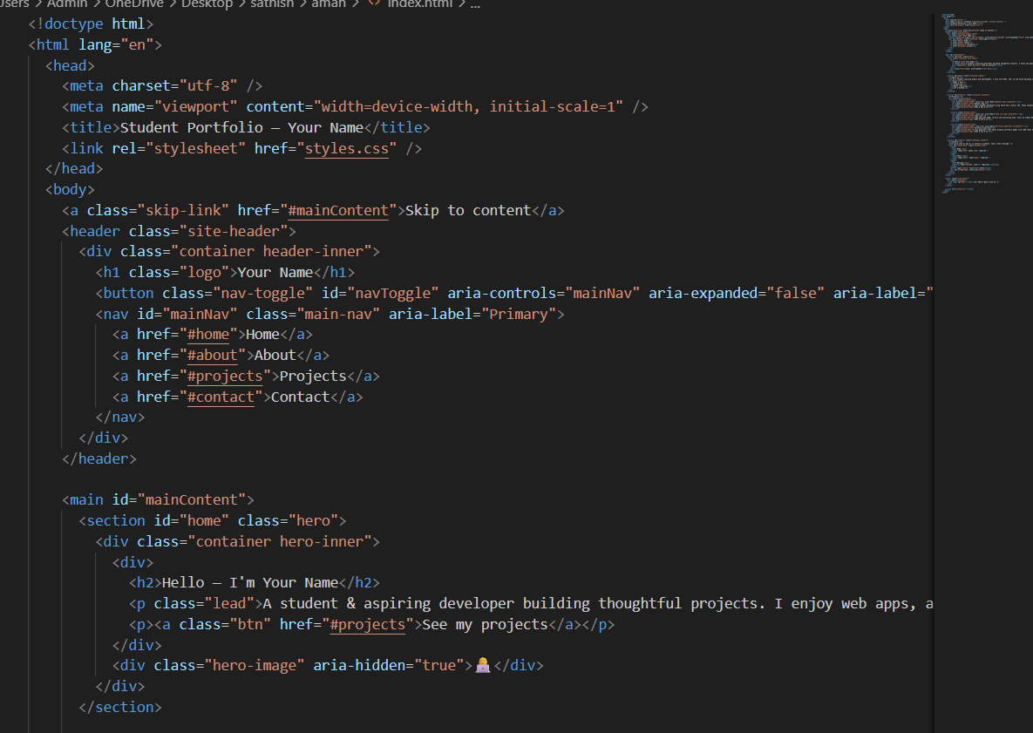

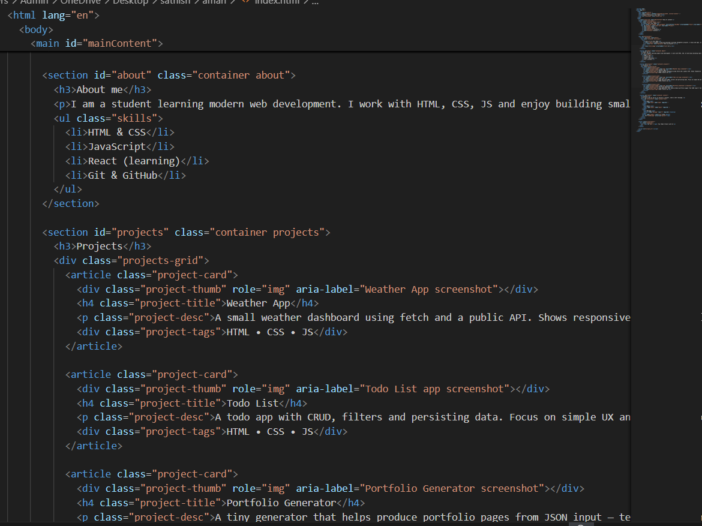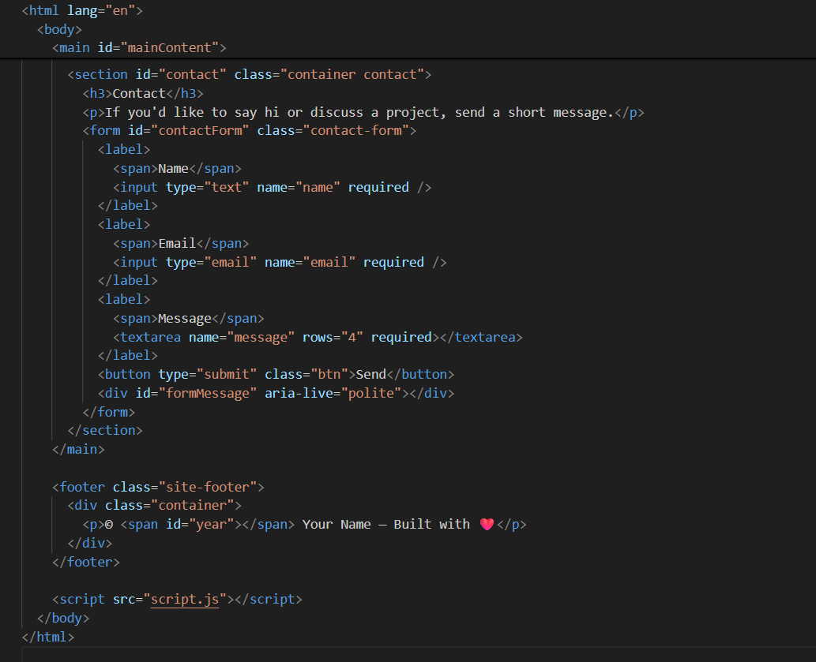

NOW IAM ADDING
CSS AND JAVA SCRIPT STYLESHEETS

First css file
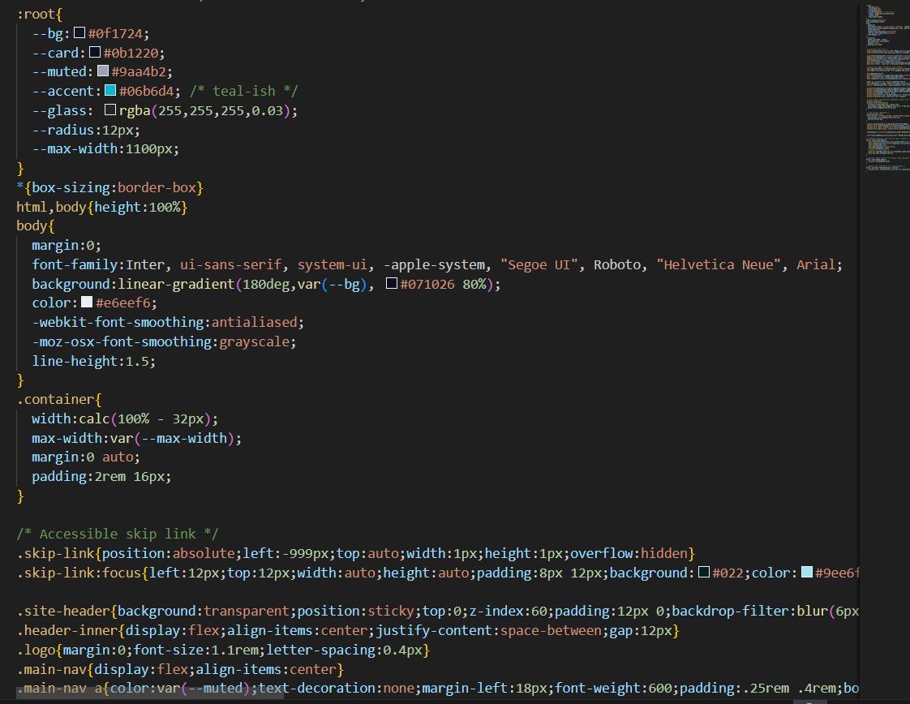

Second page of the css file
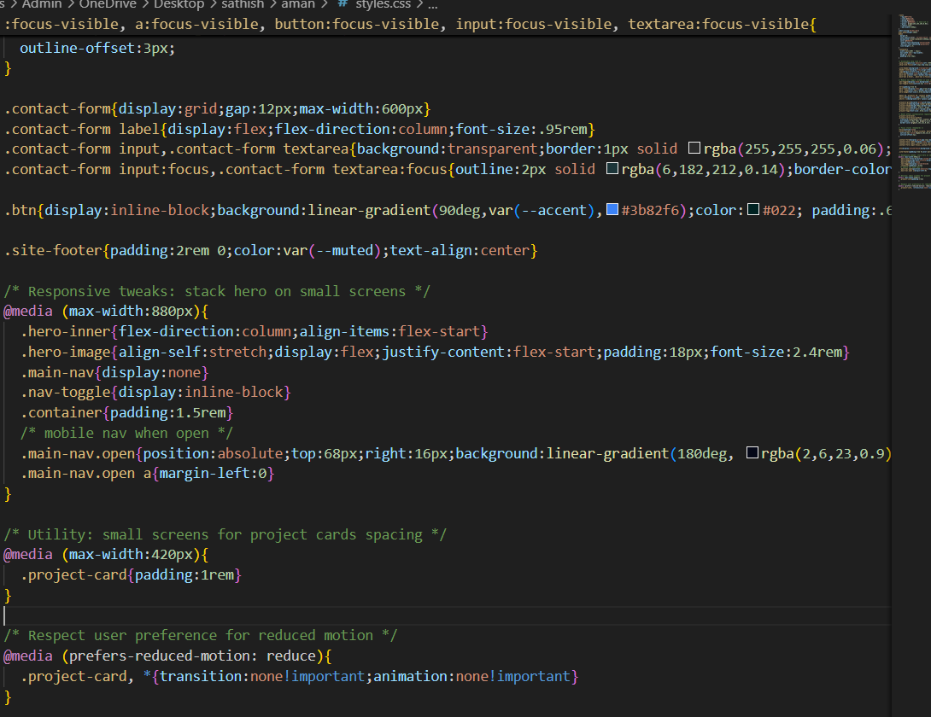

NOW java script files
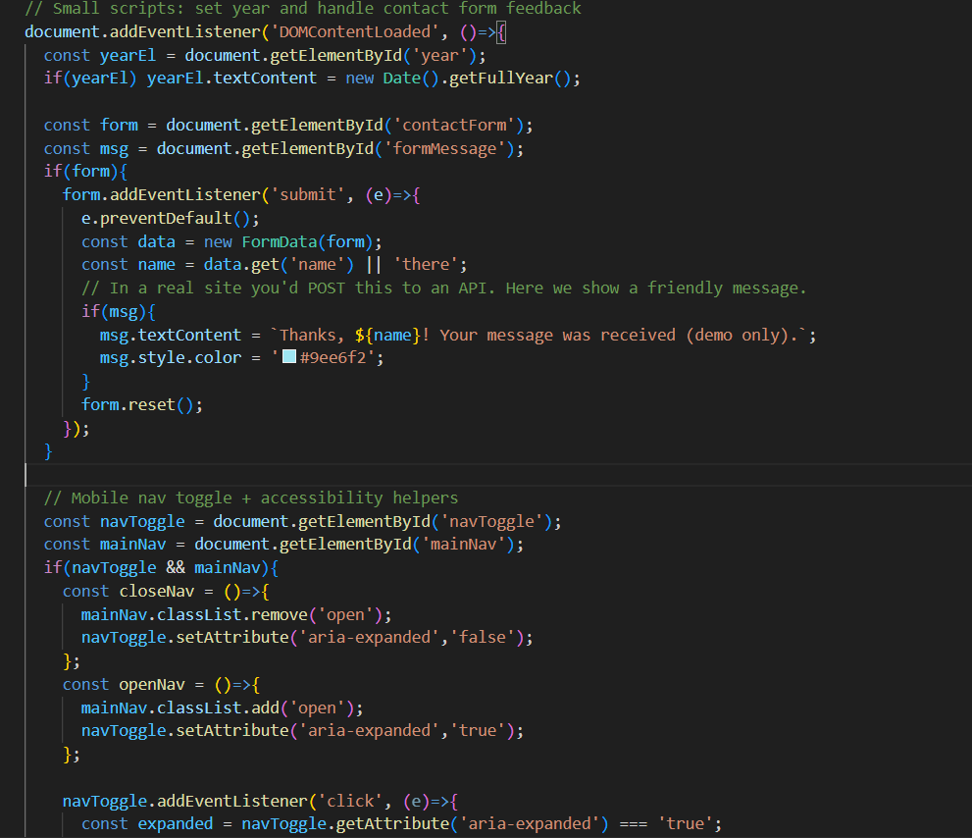

Second page of JS
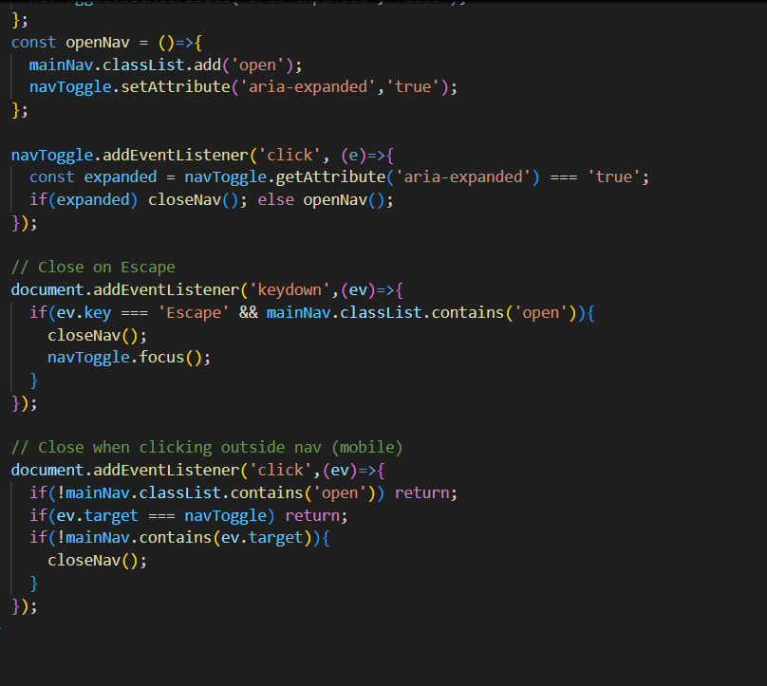

I have completed my task using the above codes
link:file:///C:/Users/Admin/OneDrive/Desktop/sathish/aman/index.html

Task 2: AI-Generated Restaurant Landing Page
Scenario:
A local restaurant needs a simple landing page with a navigation bar,
menu highlights, and an image gallery. The developer wants to quickly
generate it using AI assistance.
• Use Copilot to create a navigation bar with links (Home, Menu,
Gallery, Contact).
• Generate a menu section styled with CSS cards.
• Add a JavaScript-based image slider for the gallery, with
Copilot suggesting the base code

HTML CODE OF RESTUARENT
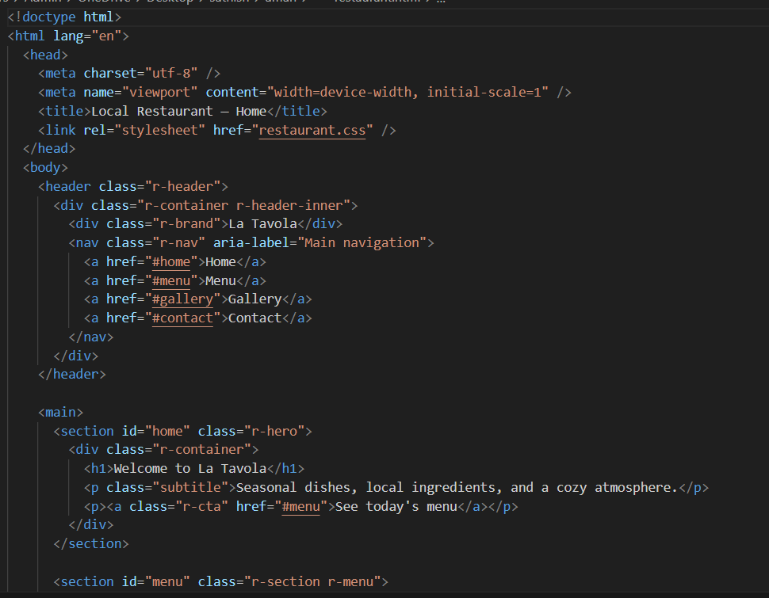

Second page of html code
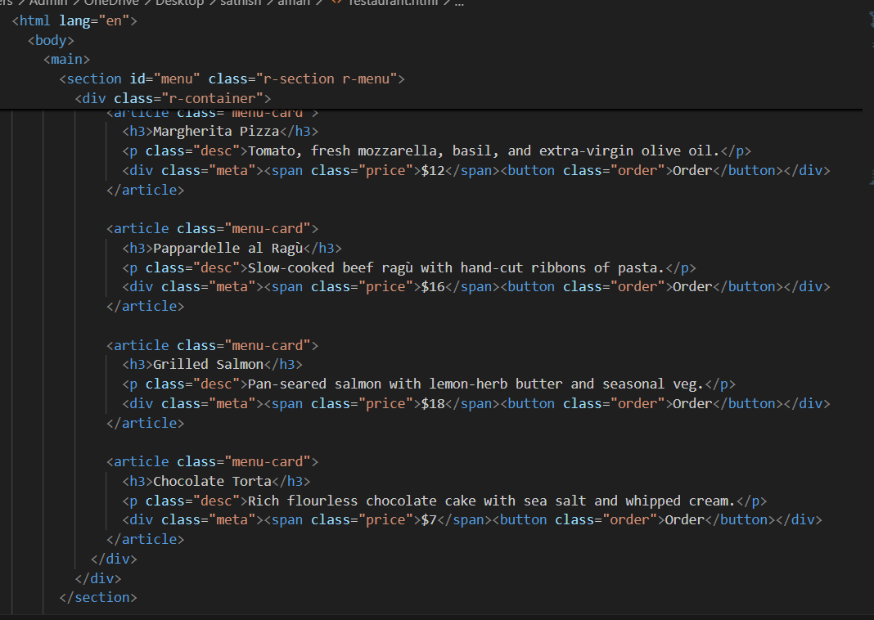

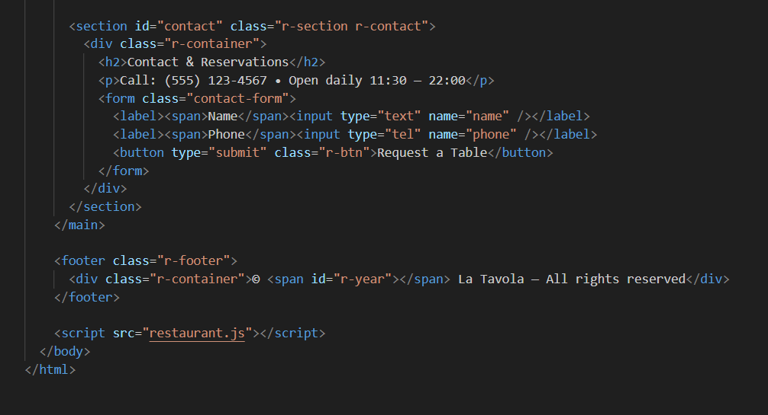
THE HTML CODE WAS COMPLETED
NOW IAM ADDING CSS STYLING TO THE HTML CODE
CSS CODE OF RESTUARENT
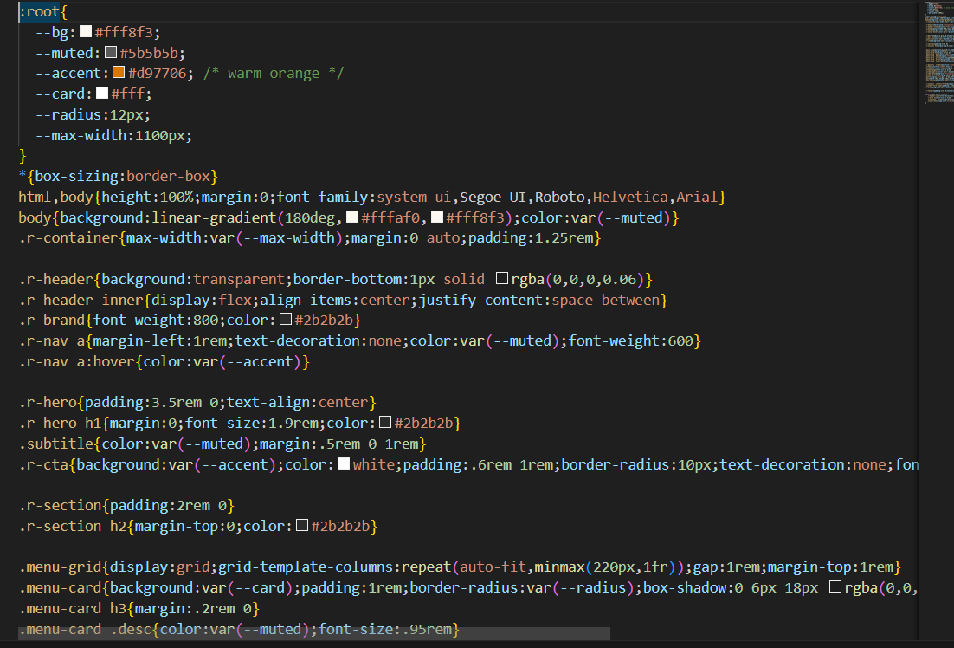

SECOND PAGE OF CSS CODE
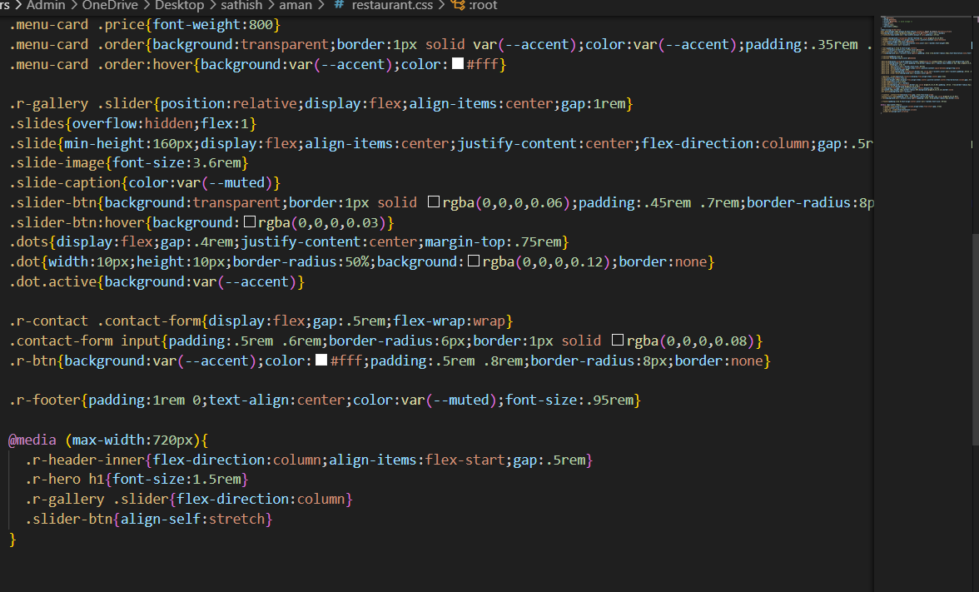

JAVA SCRIPT CODE OF THE RESTUARENT
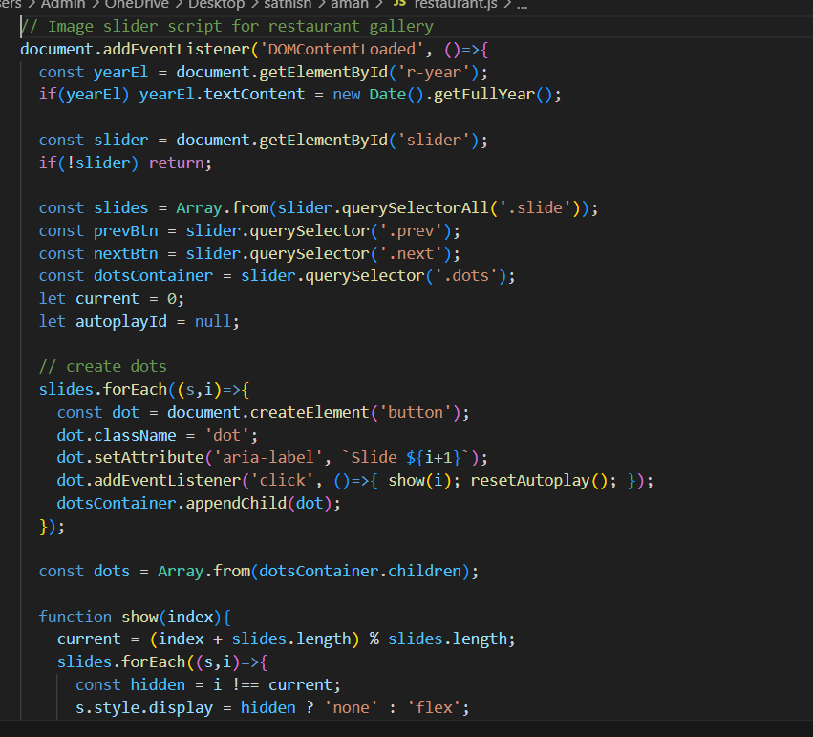

SECOND PAGE 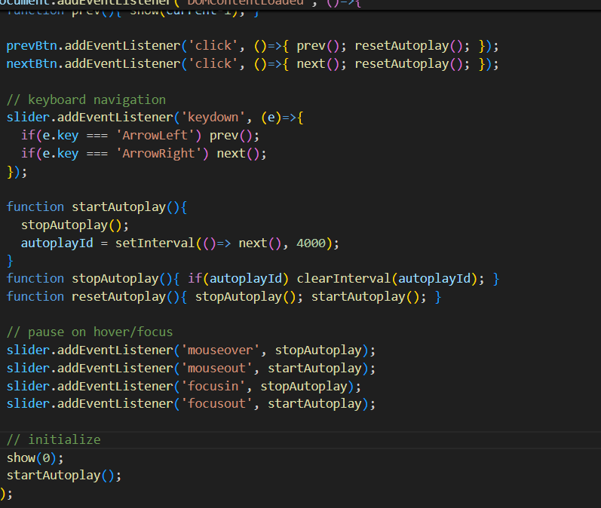
Task 3: AI-Powered Event Registration Form
Scenario:
SR University is hosting a tech fest. They need a web-based registration
form for students. The form must validate user input in real-time.
• Ask Copilot to generate an HTML form (fields: Name, Email,
Phone, Department, Event Selection).
• Use Copilot to assist in adding CSS styling for an attractive form
layout.
• Implement JavaScript validation (e.g., email format check,
phone number length check) using Copilot’s suggestions
HTML CODE OF THE SR UNIVERSITY
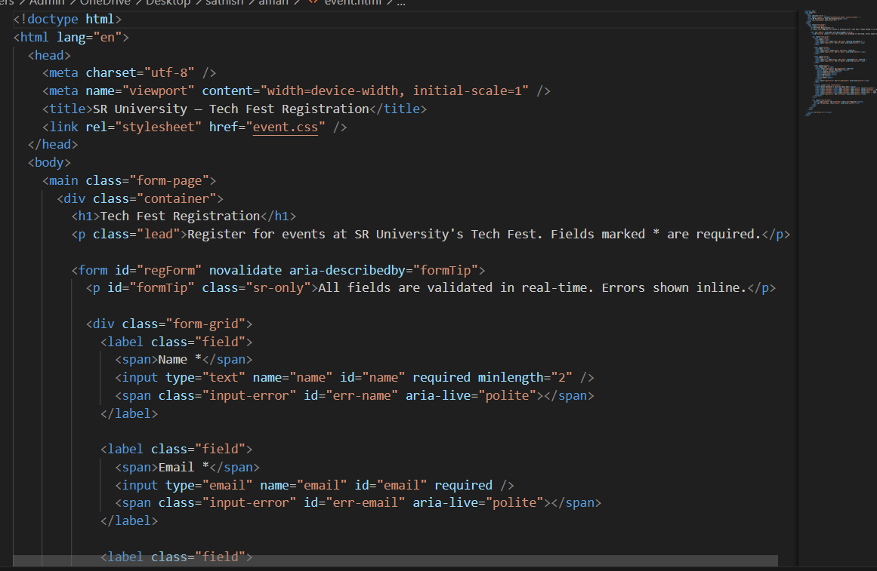

SECOND PAGE OF HTML CODE
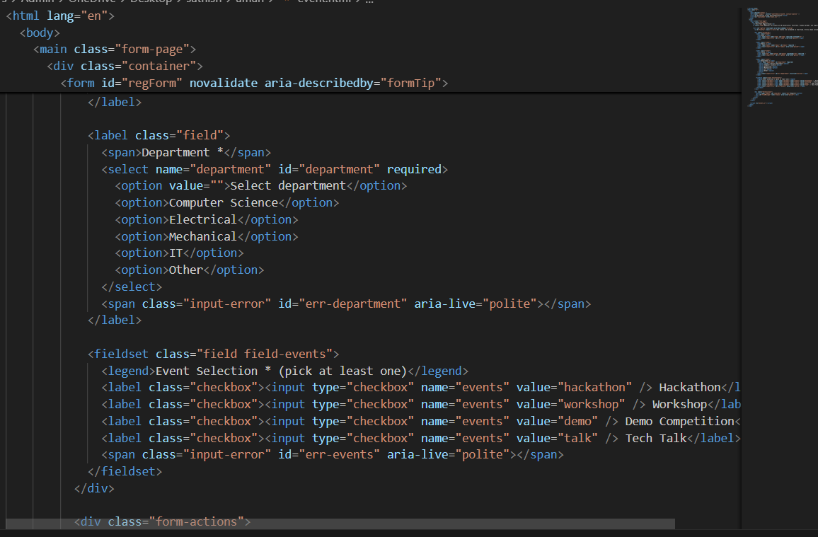

THIRD PAGE:OF HTML CODE
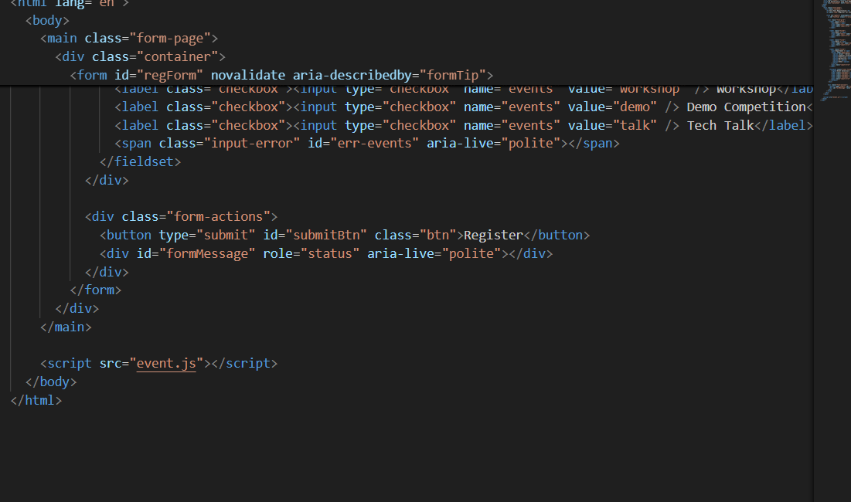
CSS CODE OF THE SR UNIVERSITY
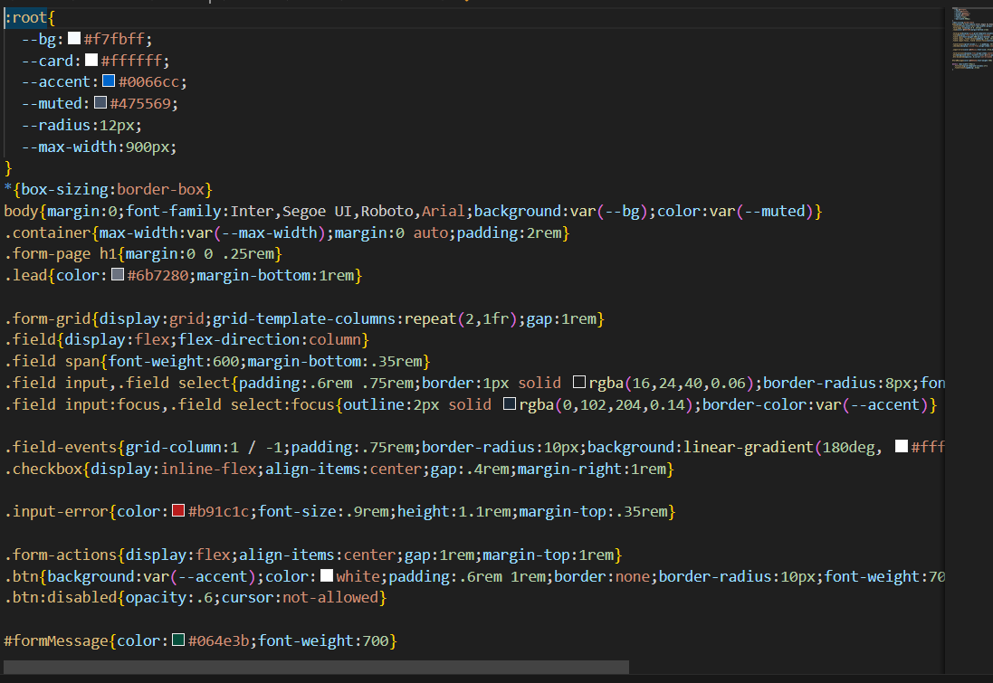

JAVA SCRIPT CODE OF THE PROGRAM
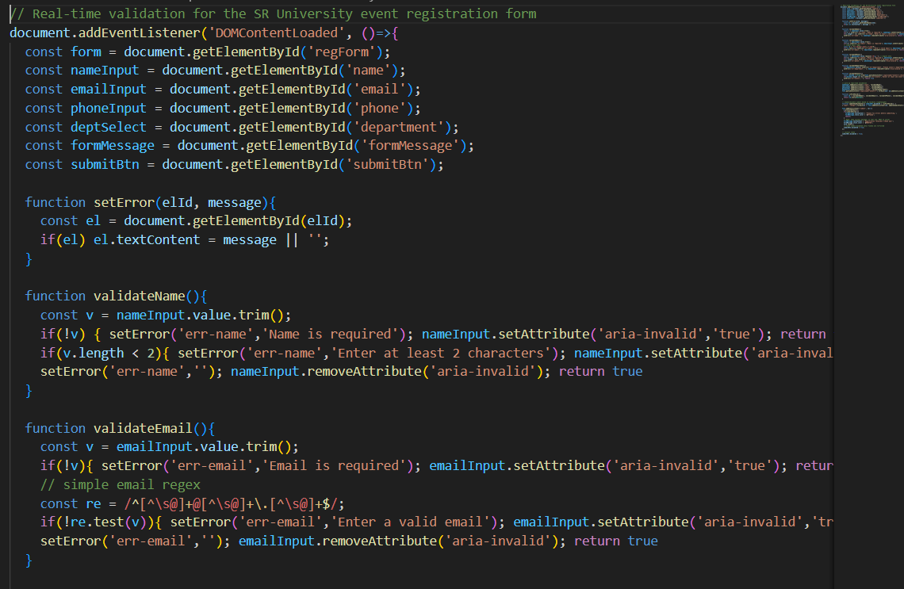

JAVA SCRIPT CODE OF THE PROGRAM
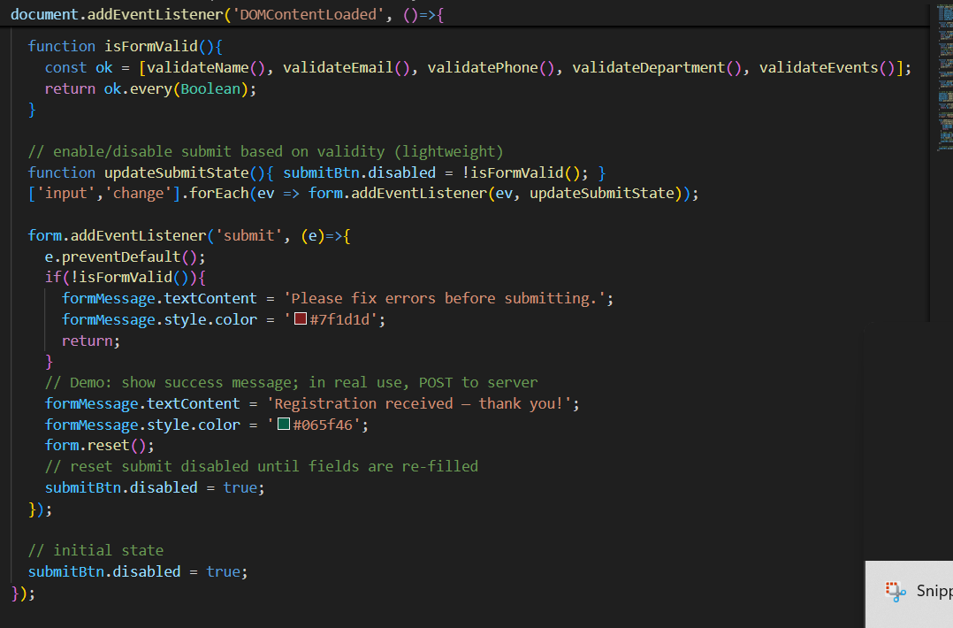

LINK: "C:\Users\Admin\OneDrive\Desktop\sathish\aman\event.html"

Task 4: AI-Assisted E-Commerce Product Page
Scenario:
A startup wants a basic e-commerce product page to display products
with prices and an “Add to Cart” button.
• Use Copilot to generate a grid-based product catalog in
HTML/CSS.
• Implement a JavaScript “Add to Cart” functionality with
Copilot’s guidance.
• Modify Copilot’s suggestions to include a cart counter at the
top-right corner of the page

HTML CODE OF ECCOMMERCE STARTUP COMPANY WEBSITE
FIRST PAGE OF HTML
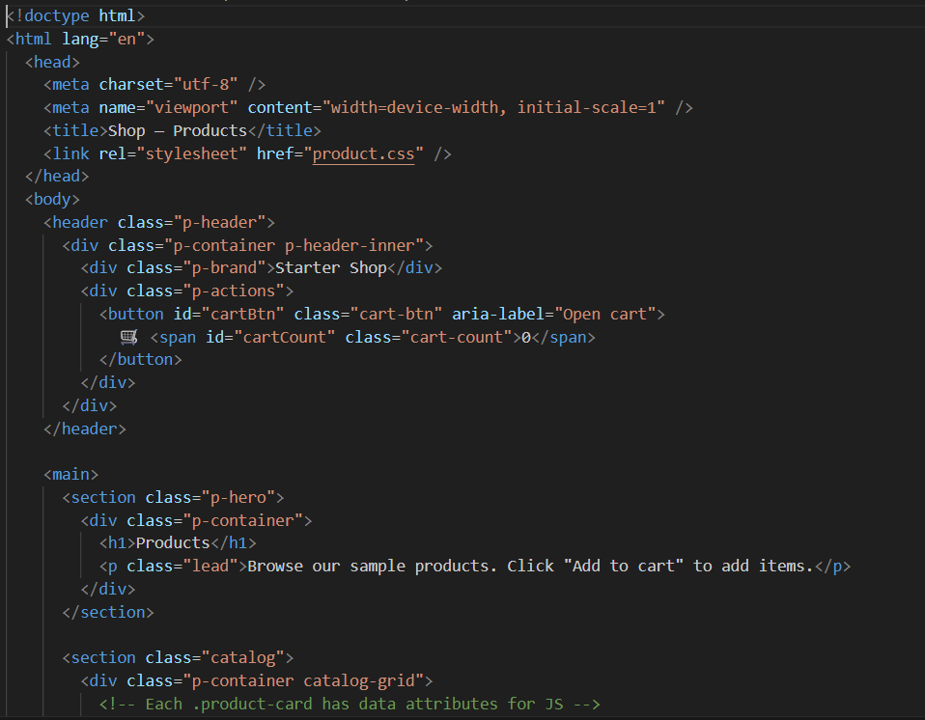

SECOND PAGE OF THE HTML CODE
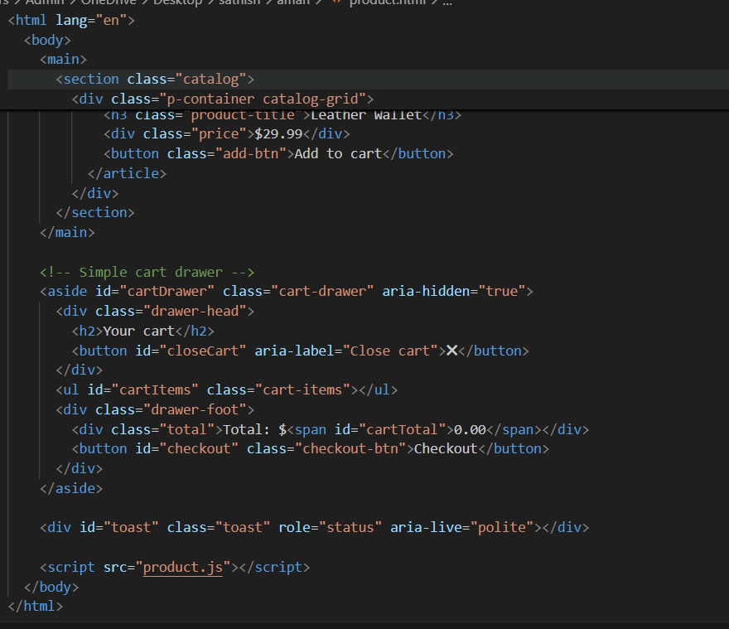

NOW IAM ADDING CSS STYLE TO THE HTML FILE OF THE PRODUCT
CSS CODE:
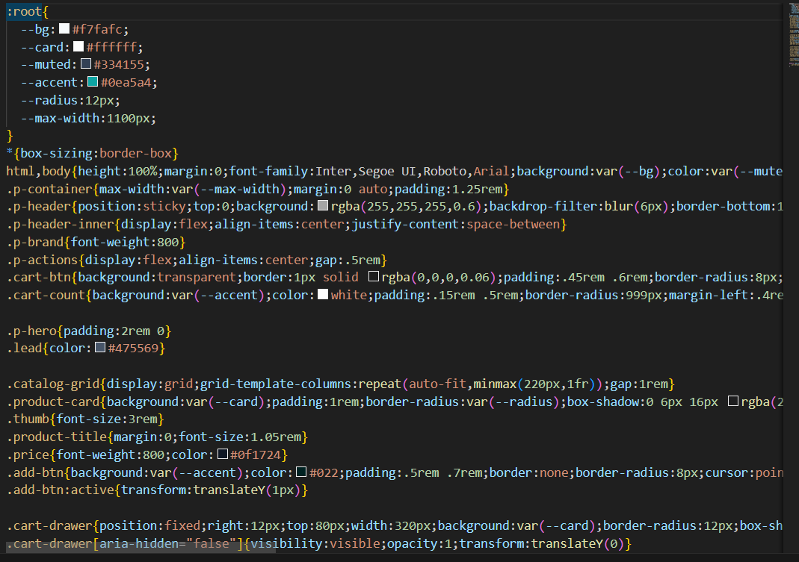

SECOND PAGE OF THE CSS CODE
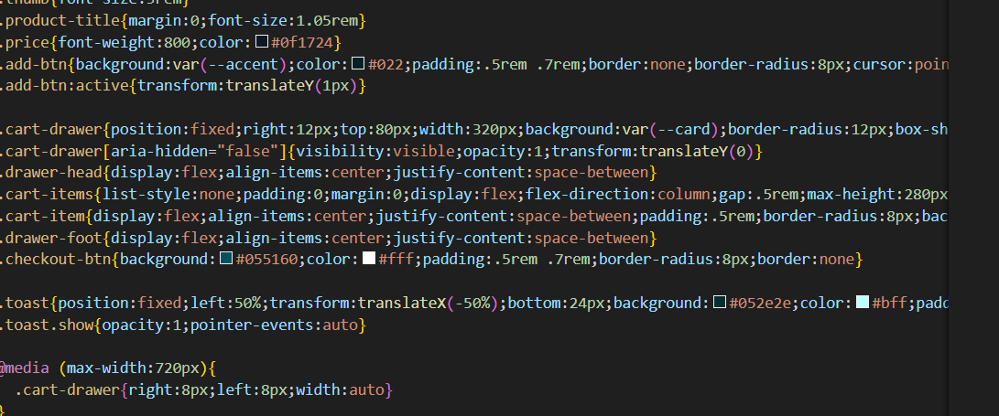

JAVASCRIPT CODE: 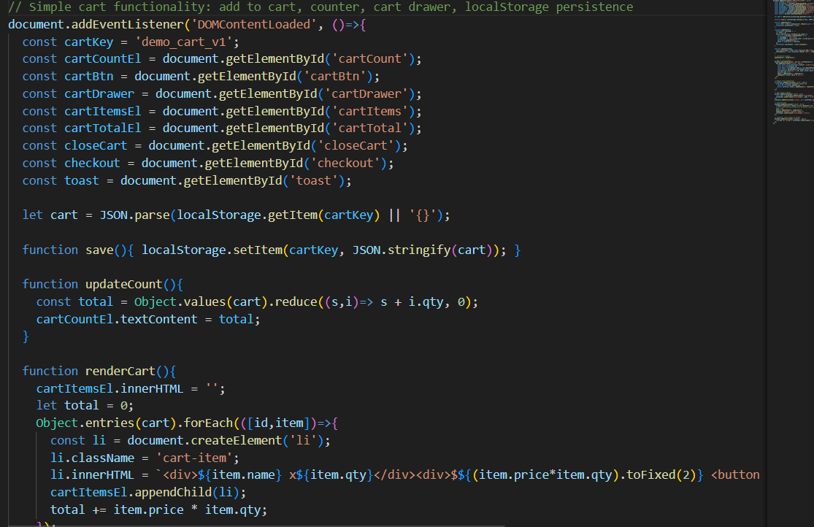
SECOND PAGE CODE
